**Product: Fin. ToDo Manager**

Fin. would allow you to keep track of your daily tasks the way you want it to be tracked.

When the application is launched, the user is immediately taken to the number

**Command-line user interface for power users**

In Fin., a command-line textbox will be there for power users to use features of the application. However, for users who are not keen on using the keyboard for all their interactions with the task manager, all functionalities that are exposed through the command-line interface can be emulated with series of clicks through the graphical user interface. The main gist is, whatever you can do with the keyboard, you’d be able to do the exact same thing with the mouse.

To start, you can type in commands at the bottom of the command-line interface. 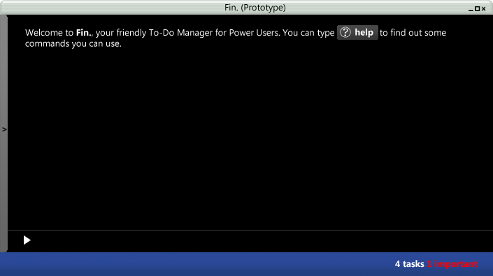

**Smart parsing of commands**

Users can add tasks with hash tags and meta tags, for example, “**Add #CS3230 #tutorial 3 due by this Friday**”. If you notice from the diagram below, as commands are typed, they will be automatically parsed and changed into actual commands to provide visual feedback to the user to ensure he is typing the right thing.

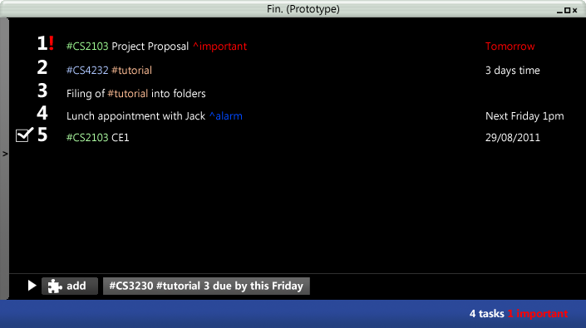

**Tags and Meta-Tags**

One of the cool things that you can do in Fin. is to add tags to your task. Another kind of tags that you can add are meta-tags

This can be done through the command-line interface by pre-pending “#<tag name here>” to your tasks. For example, to add a task with the tag “CS2103”, one can easily type “#CS2103 Project Proposal”. To add tasks with multiple tags, type “#CS2103 Project Proposal”.

**Task Recurrence**

To add tasks that are due weekly, you can type “^weekly #CS2103 Tutorial”, and a task that is reappears that this very same time in the week will appear in your task list without your intervention! How cool is that! The same functionality can be achieved by right-clicking a task that is added to edit the task.

**Subtasks**

Another cool thing that can be done in Fin. would be to break tasks up into smaller tasks. This can be done by pre-pending “^task<task number>”

**Graphical User Interface for casual users**

For every command in the command line, the same feature will be available to users who shy away from the command line. In the example below, as the mouse rolls over the tasks, there will be options to focus, edit and delete tasks.

